# INTRODUCTION

* 1. Overview

Vehicle Management System is proposed with the intention of upgrading the current stand-alone system to a web based or online system.

Proposed to smoothen the management process of the vehicle in order to handle the registration and scrapping it. This stand alone concept to web based system, i it helps staffs to store and manage data efficiently and in more organized manner. -System also accept information about the accident report, So that none of the accident goes unattained.

* 1. Purpose

Salesforce offers a Vehicle Management solution that allows companies to track and manage their fleet of vehicles within the Salesforce platform. This solution includes features such as vehicle tracking, maintenance scheduling, and fuel consumption tracking. The solution can be integrated with other Salesforce modules such as Sales, Service, and Marketing to provide a comprehensive view of vehicle usage and performance. Additionally, it can also be integrated with GPS tracking systems to provide real-time location and status updates for vehicles

**Problem Definition & Design Thinking**

* 1. Empathy Map

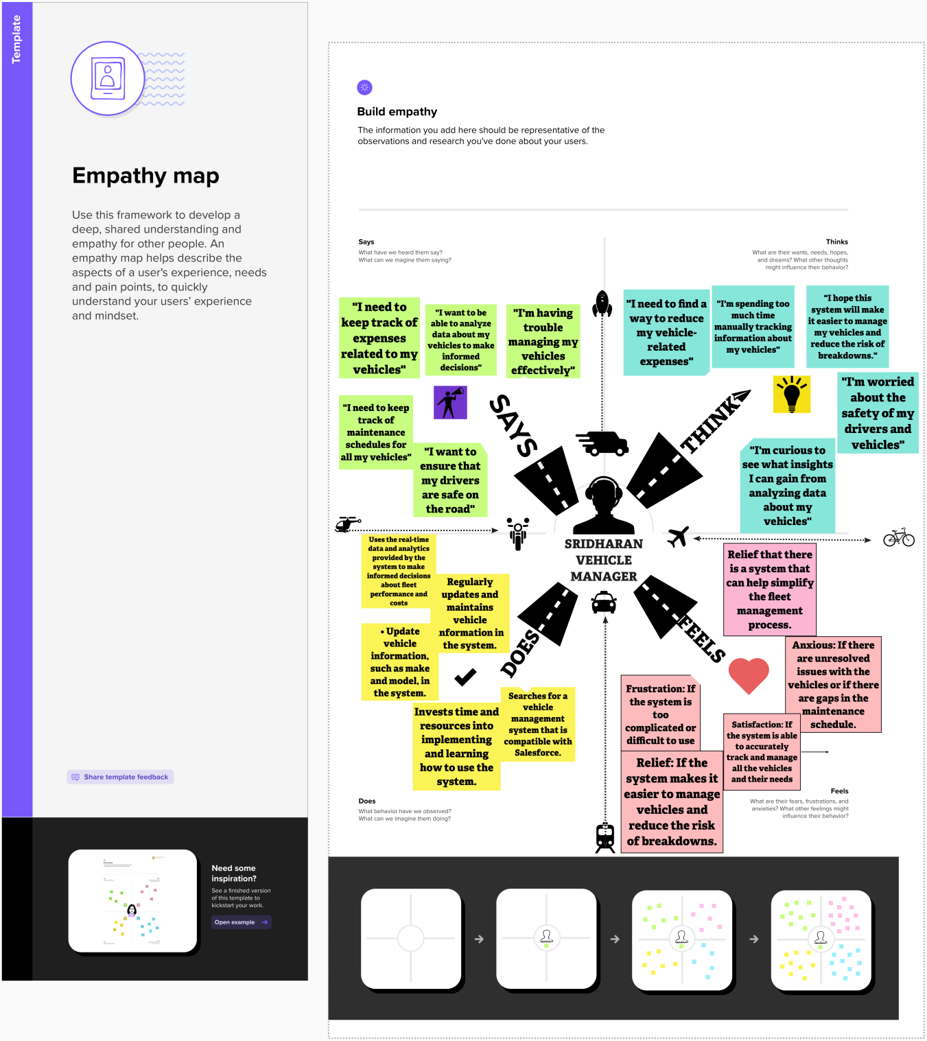

* 1. Ideation & Brainstorming Map

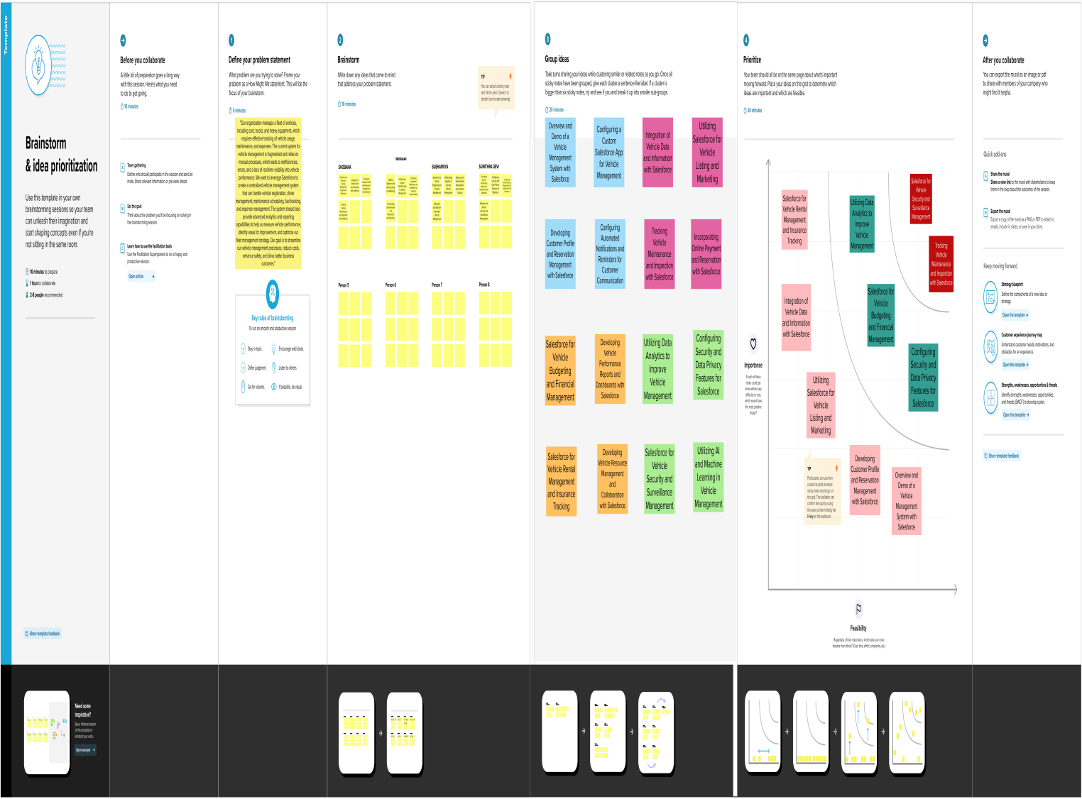

# RESULT

* 1. Data Model

Fields in Vehicles objects follow below data types:

|  |  |  |
| --- | --- | --- |
| S NO | Field Names | Data Types |
| 1. | Customer Name | Text |
| 2. | Customer Mobile No | Number |
| 3. | Vehicle Type  i)2 wheeler  ii)4 wheeler | Picklist |
| 4. | 2WHEELERS  i) HERO  ii)HONDA  iii)BAJAJ  iv)ROYAL ENFIELD  v)TVS vi)KINETIC  vii)OLA  viii)JAWA  ix)SD  x)BATTERY | Picklist |
| 5. | 4WHEELERS  i)RENAULT  ii)SKODA  iii) HONDA  iv)HYUNDAI  v)SUZUK  vi)MAHINDRA  vii)VOLKSWAGEN  viii)BENZ  ix)AUDI  x)VOLVO | Picklist |

|  |  |  |
| --- | --- | --- |
| 6. | Vehicle Name | Text |
| 7. | Vehicle No | Text |
| 8. | Chassic No | Text |
| 9. | Colour | Text |
| 10. | Body Type | Text |
| 11. | Vehicle Includes  i)Fire Extenuation  ii)First Aid Kit  iii)Multi Charger kit  iv)Stepney  v)Stereo  vi)Tool Kit  vii)Tracking Device  viii)Tyre Jack | Multi Picklist |
| 12. | Condition  i)Good  ii)Medium  iii)Least | Picklist |
| 13. | Mileage | Text |
| 14. | Seats | Number |
| 15. | Start Date | Date/Time |
| 16. | End Date | Date/Time |
| 17. | Opportunity | Lookup(opportunities) |

Fields in Driver objects follow below data types:

|  |  |  |
| --- | --- | --- |
| S No | Field | Data Type |
| 1. | Driver Name | Text |
| 2. | Licence No | Text |
| 3. | Mobile No | Number |
| 4. | Fair Per Hour | Text |
| 5. | Vehicle | Lookup(Vehicle) |

# Activity & Screenshot

# Milestone 1:Creation salesforce org:

# WhatsApp Image 2023-04-13 at 21.00.57.jpeg

Milestone 2:Object:

Vehicle

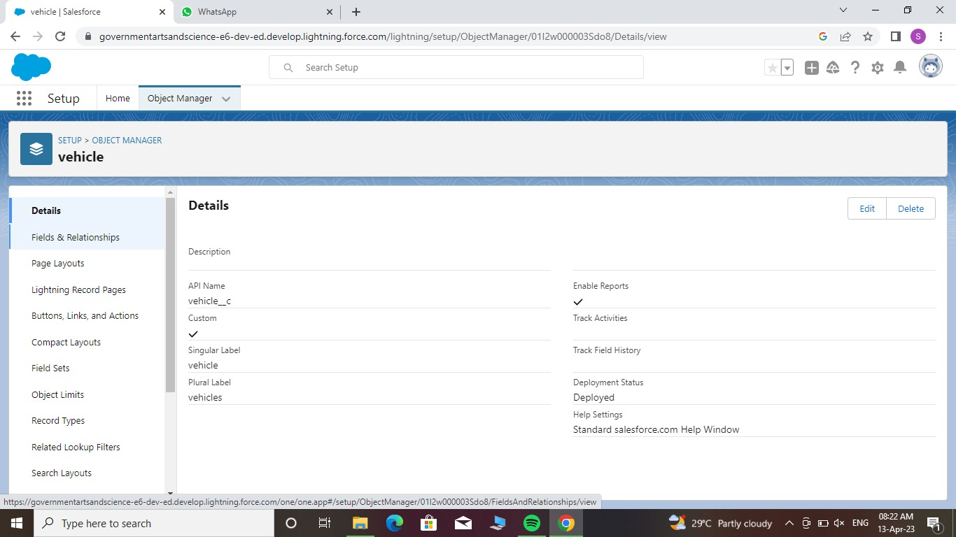

Driver

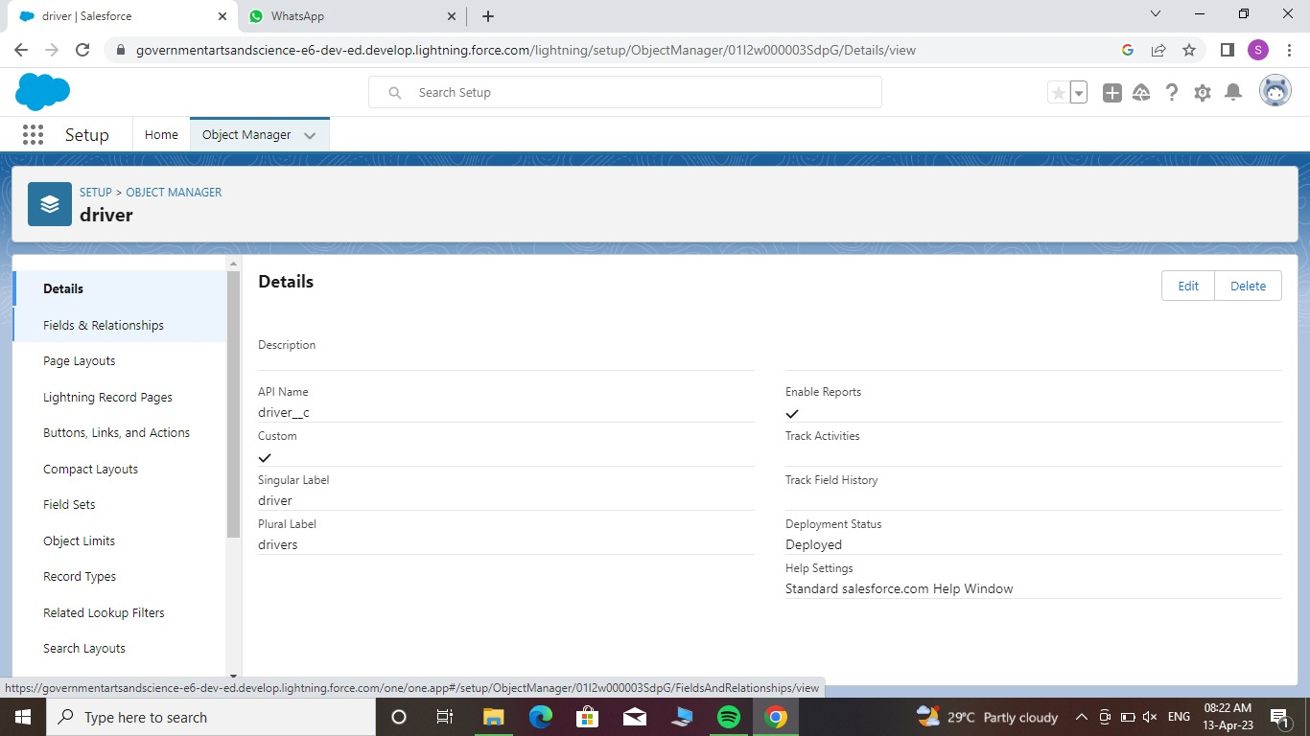

Milestone 3:Fields and Relationship:

Object 1:Vehicle

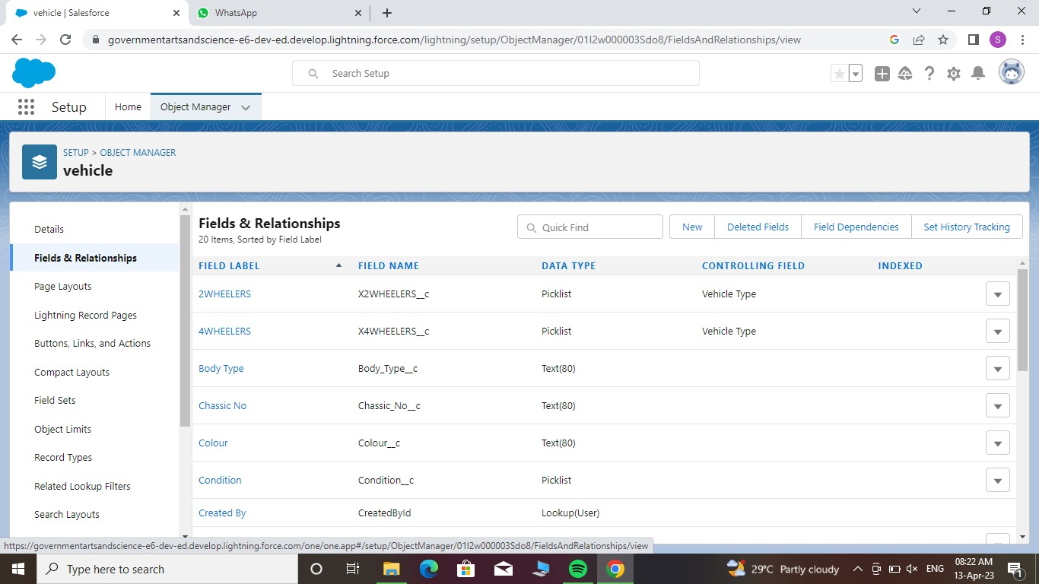

Object 2: Driver

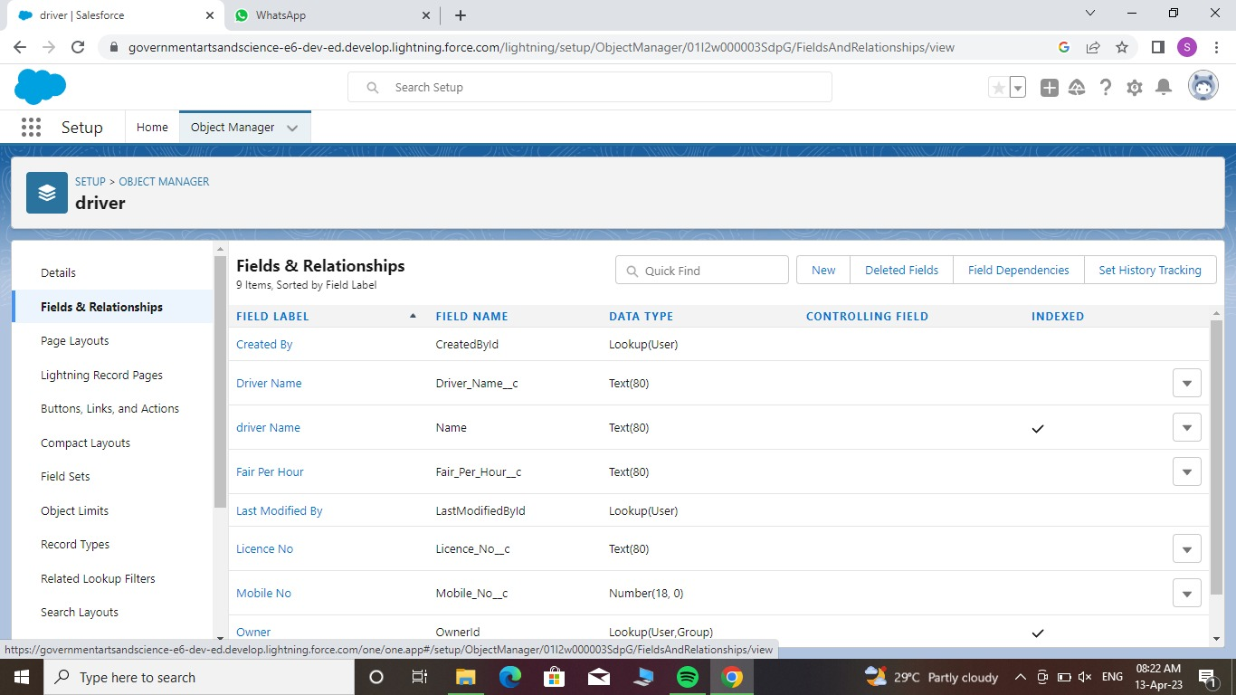

Milestone 4:Lighting App:

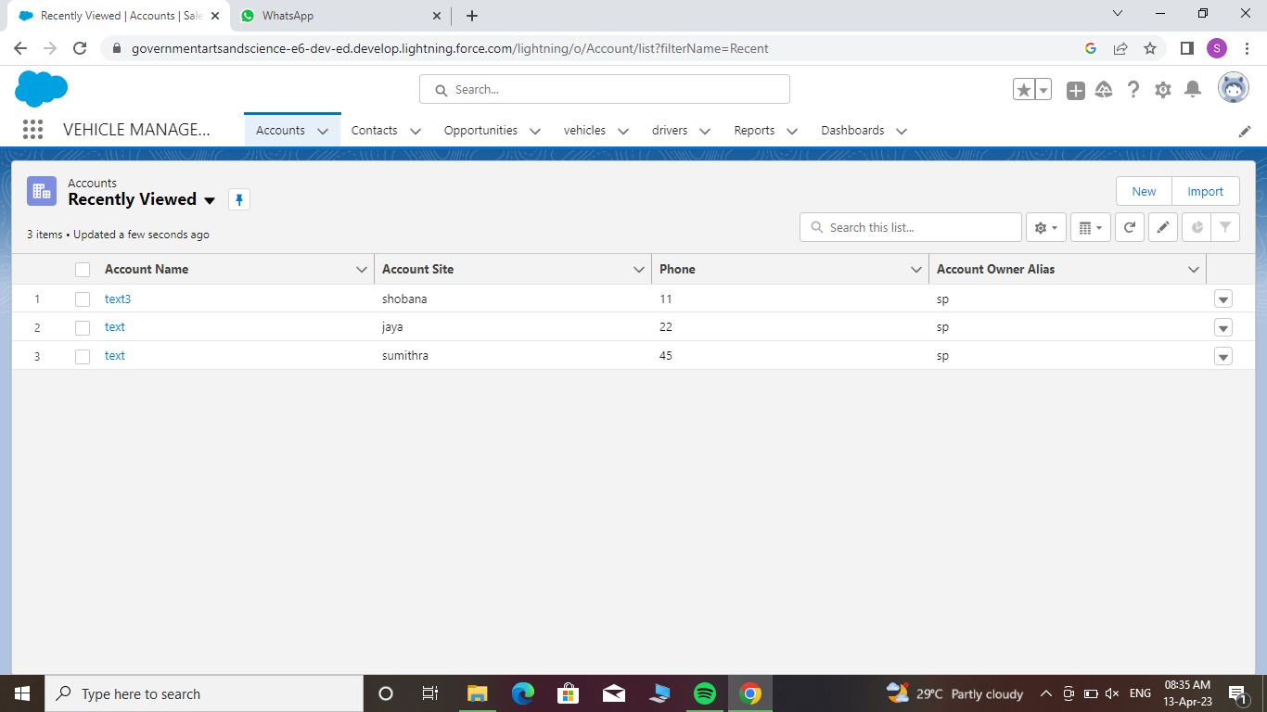

Milestone 5:Profile:

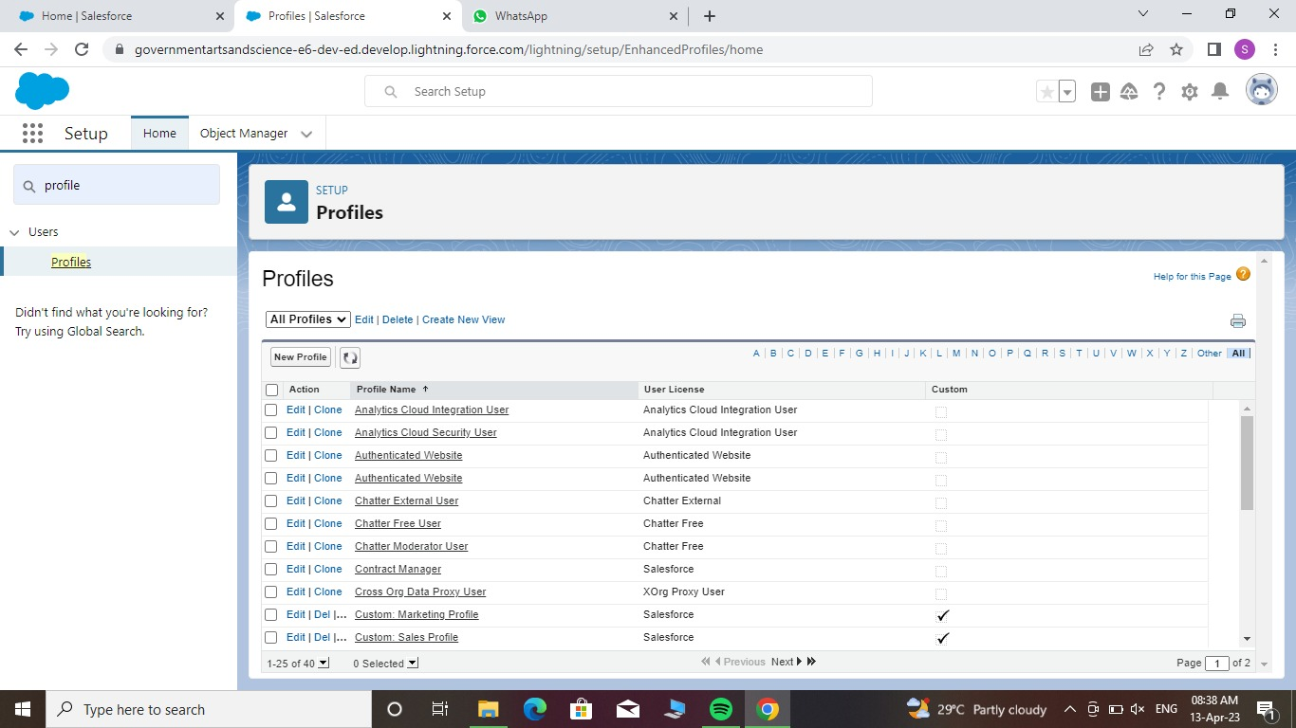

Milestone 6:Users

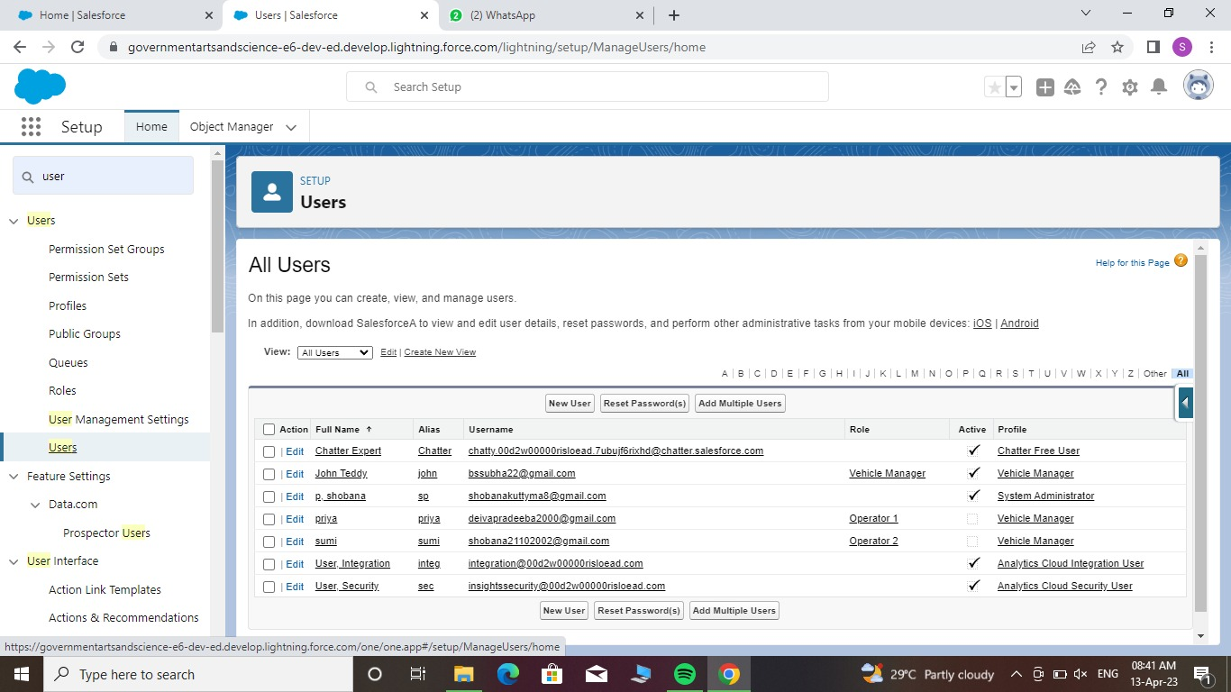

Milestone 7:Reports

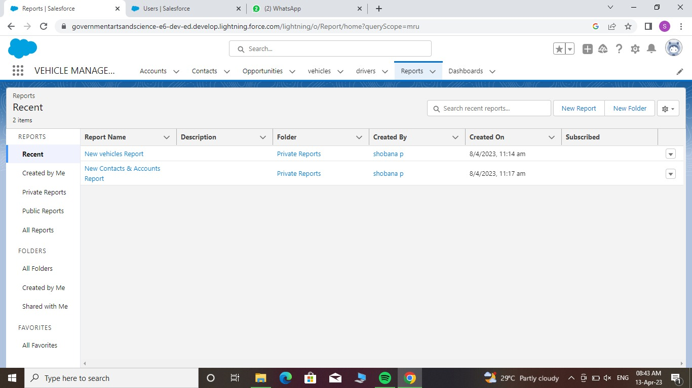

DASHBOARD:

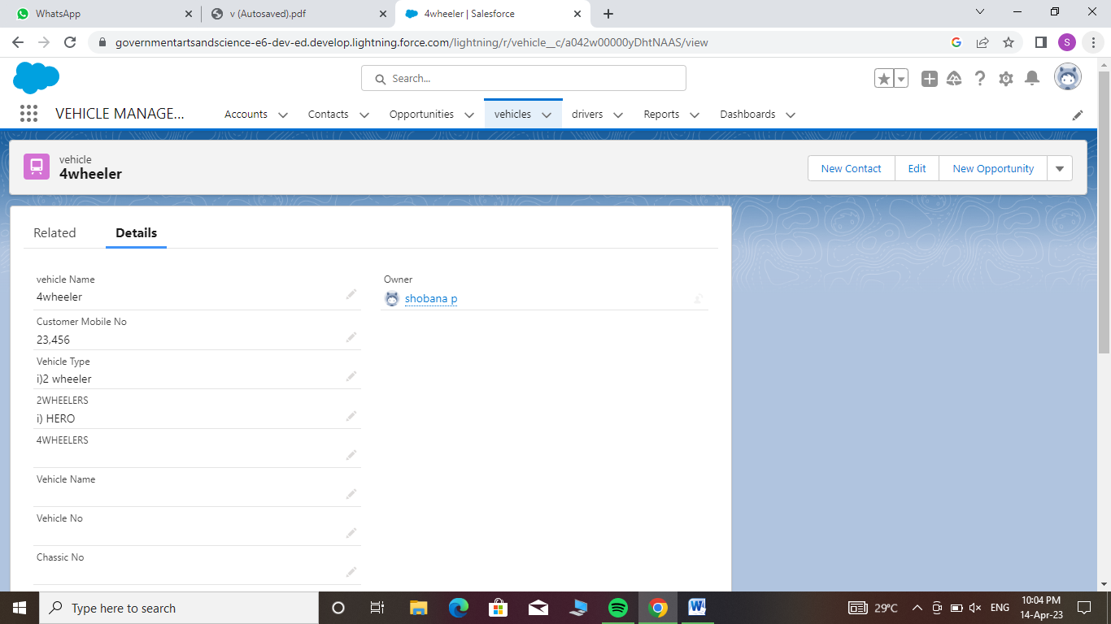

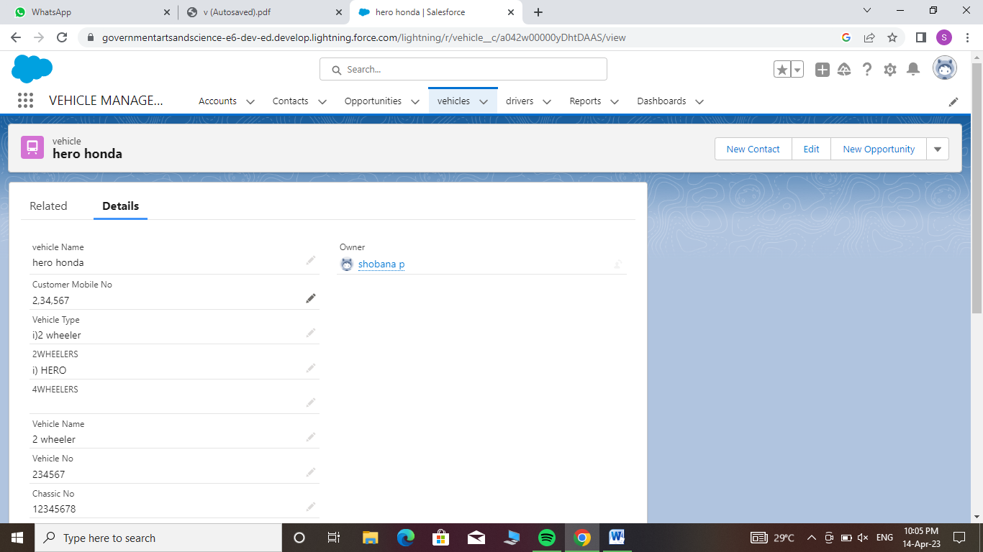

# Trailhead Profile Public URL

Team Leader- SHOBANA

[**https://trailblazer.me/id/sshobana6**](https://trailblazer.me/id/sshobana6)

Team Member 1-SRIDHARAN

[**https://trailblazer.me/id/sridr15**](https://trailblazer.me/id/sridr15)

# Team Member 2- SUBHA PRIYA

# 

# <https://trailblazer.me/id/subhb4>

# Team Member 3 –SUMITHRA DEVI

# <https://trailblazer.me/id/sdevi339>

1. **ADVANTAGES & DISADVANTAGE**

**Advantages - Vehicle Management**

Duplication of the vehicle data is avoided

As vehicle number is already stored in the master therefore human mistakes can be avoided

⚫t Timely alerts ensure that penalties are avoided

Depending on the type of fleet being managed,

a vehicle management system can reap a few or more business benefits.

Not withstanding that it largely depends on the quality of management conducted by the fleet owner, fleet manager or fleet operator, even mere few of these benefits can make a real difference in the fleet's performance efficiency, with substantial impact on ROI. That is to say, it may make the difference between a fleet of assets and a fleet of liabilities.

**Disadvantages of Fleet Management:**

Active tracking based fleet management requires monthly subscription charges and data usage charges.

It is difficult to manage and maintain fleet management system due to use of multiple technologies such as cloud servers, cellular wireless systems, fleet management software etc.

It requires skilled resources to maintain such system. This increases maintenance costs.

GPS device used in fleet management is power hungry which drains battery faster.

GPS signal does not pierce through the walls, solid structures, under water or dense trees. Hence it is difficult to track the fleet when they are in such regions or behind such locations.

# APPLICATIONS

# The Software Requirements Specification is produced at the culmination of the analysis task. The function and performance allocated to software as part of system engineering are refined by establishing a complete information description, a detailed functional and behavioral description, an indication of performance requirements and design constraints, appropriate validation criteria, and other data pertinent to requirements.

# CONCLUSION

# Our project is only a humble venture to satisfy the needs to manage their

# project work. Several user friendly coding have also adopted. This package shall prove to be a powerful package in satisfying all the requirements of the school. The objective of software planning is to provide a frame work that enables the manger to make reasonable estimates made within a limited time frame at the beginning of the software project and should be updated regularly as the project progresses.

# At the end it is concluded that we have made effort on following points...

# ⚫ A description of the background and context of the project and its relation to work already done in the area.

# ⚫ Made statement of the aims and objectives of the project.

# ⚫ The description of Purpose, Scope, and applicability.

# ⚫ The description of Purpose, Scope, and applicability.

# • We define the problem on which we are working in the project.

# • We describe the requirement Specifications of the system and the actions that can be done on these things.

# • We understand the problem domain and produce a model of the system, which describes operations that can be performed on the system.

# • We included features and operations in detail, including screen layouts.

# • We designed user interface and security issues related to system.

# Finally the system is implemented and tested according to test cases.

# FUTURE SCOPE

In a nutshell, it can be summarized that the future scope of the project circles around maintaining information regarding:

⚫ We can add printer in future.

We can give more advance software for Vehicle Management System including more facilities

⚫ We will host the platform on online servers to make it accessible worldwide

• Integrate multiple load balancers to distribute the loads of the system

• Create the master and slave database structure to reduce the overload of the database queries

⚫ Implement the backup mechanism for taking backup of codebase and database on regular basis on different servers